INTRODUCTION TO IVERILOG

Design: The verilog codes which functions to meet the sepcification is called the design

Simulation: The process of checking the RTL Design, if it is meeting the required spec is the simlation

Tool Used: iverilog (open source tool)

Test Bench: Is the setup done by giving the stimulus(test vectors) to the design to verify if it matches with the specs

How Does a Simulator Work?

=> Only when there is a change in the input, there will be a change in the output in the simulator

How Does a Testbench Work?

=>The Design is instantiated in the testbench

=>There is a stimulus generator that gives the primary inputs to the design

=>There is a stimulus observer which observe the primary outputs from the design

=>There is no primary input/primary output in the testbench

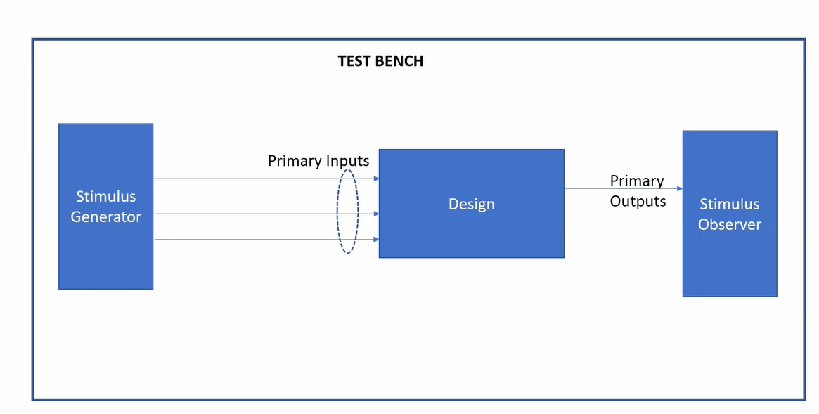

iverilog simulation flow

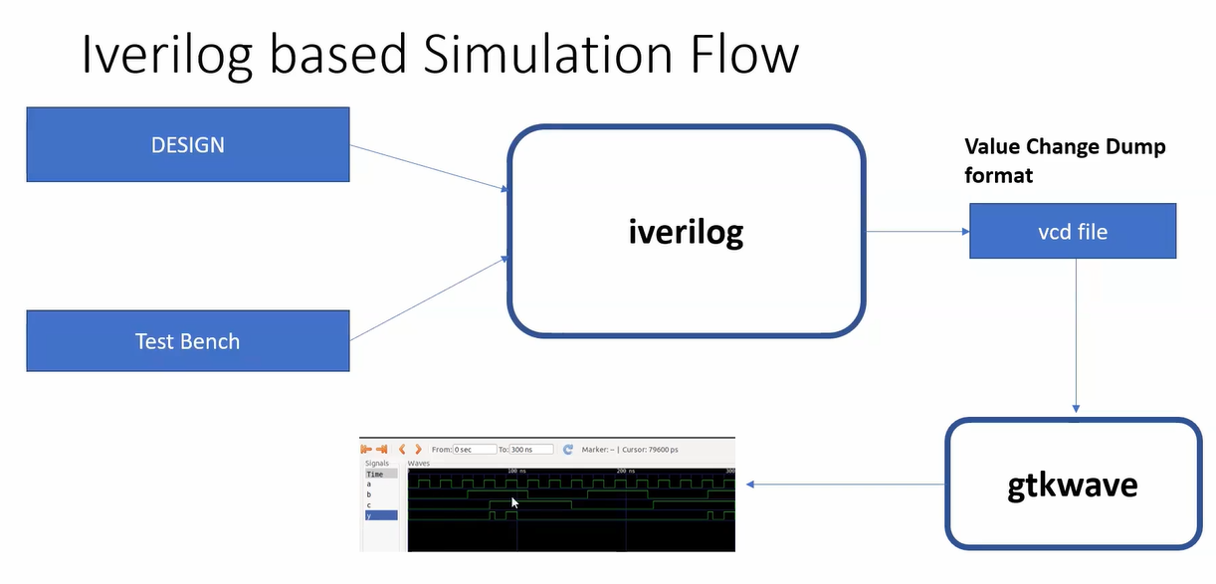

=>The Design & Testbench are given to the iverilog

=>The file generated from iverilog(simulator) will be a vcd file(value change dump) => when there is a change in the input, there is a change in the output => these changes are noted and dumped in the file.

=>the vcd file can be viewed in the gtkwave(waveform viewer)